|  |  |
| --- | --- |
| **REPORT TO** | **ON** |
| **CABINET** | **21 June 2018** |
|  | |
| **TITLE** | **PORTFOLIO** | **REPORT OF** |
| **First Phase of Campus Programme** | **Cabinet Member (Public Health, Leisure and Wellbeing)** | **Director of Neighbourhoods and Development** |

|  |  |
| --- | --- |
|  | |
| Is this report a **KEY DECISION** (i.e. more than £100,000 or impacting on more than 2 Borough wards?)  Is this report on the **Statutory Cabinet Forward Plan**?  Is the request outside the policy and budgetary framework and therefore subject to confirmation at full Council?  Is this report confidential? | **Yes**  **Yes**  **No**  **No** |

**1. PURPOSE OF THE REPORT**

* 1. The purpose of this report is to identify the initial 1st phase works of the Campus Programme, quantify the spending in 2018/19 and seek Cabinet approval to progress the work. Approval is also sought for the preferred procurement route for the leisure element of the Leyland Campus and seek authority to commence that.

1. **PORTFOLIO RECOMMENDATIONS**
   1. Cabinet approve the schedule of works described in section 6 including Project Management, Green Infrastructure (Green links identified in Appendix C for 2018/19), Existing Built Assets, Leisure Facility and Sports Pitch Hub which are within the approved Capital Strategy and grant authority to spend on those schemes;
   2. Cabinet endorse the procurement route for developing the leisure element of the Leyland Campus and approve the procurement of the development team via a single source, direct award framework as described in section 6.5. (Pagabo/perfect Circle Framework);
   3. Cabinet authorise the commencement of work on the Leyland Campus Master Plan including public consultation which will then be submitted to Planning Committee at a later date.
2. **REASONS FOR THE DECISION**
   1. Council approved the Capital Strategy on 28th February 2018. Development of campuses is a key element of the Health and Wellbeing priority within that Strategy. Cabinet approval is required for the detail within the overall Strategy to allow expenditure to be incurred in 2018/19 and progress to be made.
   2. The appointment of a development team for the leisure element of the Leyland Campus is essential to move the project forward. Without this the project and hence the whole programme would stall. The single source direct award from a framework is the best route for the Council to secure the wide range of services required. This route will ensure compliance with Official Journal of European Union (OJEU) procurement process, secure best value and enable the Council to move forward. This route will also build in flexibility for the Council to adjust the resources required as the project evolves.
3. **CORPORATE PRIORITIES**
   1. The report relates to the following corporate priorities:

|  |  |
| --- | --- |
| Excellence and Financial Sustainability |  |
| Health and Wellbeing | X |
| Place |  |

Projects relating to People in the Corporate Plan:

|  |  |
| --- | --- |
| People |  |

1. **BACKGROUND TO THE REPORT**
   1. Health and Wellbeing is a major priority within the Council’s Corporate Plan. This programme has evolved with the development of the Campus programme for South Ribble. A Cross Party Member Working Group worked with Officers to develop the Campus Concept for the Borough. This high level concept was agreed at Cabinet on 6th December 2017. It involves leisure investment but is much wider. A key outcome to improve health of our residents is to increase their participation in physical activity. Members of the Working Group recognised that this is wide ranging and would require investment in the great green assets in the Borough and the links between them making it easier to access and use them for walking, cycling and other outdoor pursuits. It also recognised that investment is required in leisure facilities and there is a positive business case to do the 1st stage.
   2. For the full benefit to be derived, many key partners need to come together to bring about step change. However, Members have examined options to use Council investment to start the programme. The programme proposed makes investments in green infrastructure, existing assets and delivers a new leisure facility as the first part of a Leyland Campus.
   3. The Capital Strategy includes a 5 year programme that will make a significant improvement for residents. This report sets out the proposed detailed spend in 2018/19 and the outcomes that will be delivered from that expenditure.
   4. Delivery of the leisure element of Leyland Campus is a major project in its own right. A wide range of skill will be required to move forward to design, plan and deliver the scheme over the next 3 years. This report looks at the how to deliver the necessary skill to achieve the desired outcomes and the appropriate procurement route.
   5. Work is on-going with Sport England at a national level to link with their agenda and emerging themes. The Campus proposal is much more than specific leisure schemes and looks at comprehensive action to improve health outcomes for all of the residents. Sport England, as part of a national agenda, are looking at how they fund wider activity to increase health outcomes as well as participation.
   6. Growth proposals in the Local Plan and involvement in City Deal means that across South Ribble and Preston we will see more than 20,000 new private sector jobs, and over 17,000 new homes built. This growth brings opportunity and challenge. Our services and amenities equally need to respond to the challenge of growing demand and expectations. The “Campus Programme” is pro-active action to provide services that are more effectively joined up, to use resources to best effect and to deliver improved outcomes for the people of South Ribble. This is seen as a positive contribution to City Deal.
2. **PROPOSALS** 
   1. The complete capital strategy for the Authority is shown in Appendix A. The programme for 2018/19 for Health and Well Being is shown in the table below. Cabinet approval is required for specific spending within these agreed provisions.



The following sections describe the detailed proposals within these categories. Cabinet approval is sought for each part. The proposals before Cabinet are specific and can be delivered. They do not amount to the whole programme as further work on specific proposals is required before Cabinet can make an informed decision. These proposals will come forward in due course.

* 1. **Project Management**
     1. Approval is sought to appoint a Programme Director for the Campus Programme. This role will oversee the whole programme fulfilling all client side responsibilities as well as specifically leading on the new build projects. This role is key to supporting the Deputy Chief Executive (Growth & Regeneration) as lead officer. The roles and responsibilities of such a post are shown in Appendix B.
  2. **Green Infrastructure**
     1. The overall programme for improving green links was highlighted in the business case approved by Cabinet on 6th December 2017. A strategy called “Our Green Links” has been developed to identify the key elements that will be carried out,materials to be used, wayfinding signage and the immediate priorities. This forms the basis of the quality required from the contractor procurement.
     2. An initial 3 year work programme has been drawn up for areas that have a long standing need for improvement. £275,000 has been earmarked for the current year and the programme outlines below.

|  |  |
| --- | --- |
|  | **£000,s** |
| Penwortham to Bamber Bridge (Inc. Longton) | 97 |
| Bamber Bridge LC via Withy Park to Tennis Centre | 16 |
| Ribble Link and connection to Central Parks | 36 |
| Central Parks | 126 |

* + 1. The detailed schemes have been drawn up by the in-house team and will be the basis of procuring a contractor to deliver. A summary of each of the above is shown in Appendix C (i), (ii), (iii) and (iv).
    2. Penwortham Holme Recreation Centre has been out of commission for the duration of the 2017/18 playing season. The site is identified in the 2012 Central Lancashire Playing Pitch Strategy (CLPPS) as a site of ‘Regional’ significance for the development of football, particularly junior football. As a key strategic site, the venue is in need of significant investment, both to the playing pitches and changing accommodation. A feasibility study from a playing pitch point of view has been undertaken. An initial assessment of the natural turf pitches has identified that the site suffers from inadequate drainage, which causes them to be inaccessible during winter months i.e. when there is most demand. In previous years limited access has been afforded to the playing pitches between the end of October and early March.
    3. New and improved drainage would restore the pitches to previous levels and allow for substantially more use of the facilities during the playing season. This site will remain a major strategic playing field site within the current Strategic Asset Review. Investment to improve usage will help will help inform the Playing Pitches Strategy that is currently underway. The cost to provide and install a new drainage system for the whole site would be in the region of £125,000. It is essential that these works are carried out in July and August so procurement will commence immediately.
    4. Concern has been raised about the impact of such work in areas that are liable to flooding. The drainage system will NOT prevent flooding but will deal better with normal rainfall and allow greater use. In terms of flooding The Environment Agency are proposing to deliver a flood defence scheme to protect Preston and South Ribble from future flooding. The scheme will extend from Preston Docks and as far up the River Ribble to the M6 Bridge at the Tickled Trout and up the River Darwen as far as Higher Walton. The scheme is intended to protect up to 2130 domestic properties, around 600 commercial properties and 1000’s more commercial properties indirectly as well as protecting some vital road and rail links. The overall area benefitting from the scheme would be around 9km2 and would be undertaken at 5 named locations with the Penwortham Holme area being one of them.
  1. **Existing Built Assets**
     1. Worden Hall needs some immediate works to make the building secure and water tight. It will need some roof repairs as well as fixing the interior. An allocation of £50,000 is required for this work. Full quotes will be obtained and work carried out over the summer. Members are keen to establish wider uses of the Hall. This is part major project and it is looking at increasing uses within the buildings. As part of the Scrutiny Review, an award is pending subject to consultation to develop a programme of works required to facilitate the wider use of the hall. This business plan will be reported to a meeting later in the year and approval for the works sought.
     2. Farmyard Cottages require re-roofing and rendering. This was part of a previous programme and the work was identified and a procurement exercise undertaken. £45,000 sought to complete this work.
     3. Withy Grove Park has been improved and has being completed this year within the carry forward funding. Green Flag inspection has been undertaken and the outcome is awaited. However, the public toilets require a refurbishment and £20,000 is sought from this provision to improve the facility in 2018/19.
     4. Penwortham Holme existing pavilion is out of commission following vandalism. It is estimated to cost approximately £75,000 to re-instate. However, the current building configuration does not allow for the continued growth of the site and a full refurbishment would need to be undertaken. Design works are being undertaken to ensure that the building can accommodate future growth and an initial scoping exercise was undertaken to cost up a refurbishment. The new facility will provide for the large numbers of young people using the playing fields and contribute positively to the Council’s emerging Playing Pitches Strategy. Detailed proposals and costs will be brought forward for approval at the next meeting.
  2. **Leisure Facility**
     1. At the outset, the route to construction of the leisure facility within the Leyland Campus needs to be considered. It is essential to South Ribble Borough Council that the design of the facility is determined at the outset and approved by Members. It will encompass the key facilities previously outlined and any emerging requirements. Members, residents and other key stakeholders will be fully engaged in the process over the next 12 months. Once the design is finalised, the cost of that facility will be determined and fixed and planning consent will be sought. A contractor will then be procured to build that facility and costs managed closely against that plan. Further approval will be sought at that time for the procurement route for a construction contractor. This process will ensure that the Council get the facility it wants at the best price.
     2. To move forward on this project the Council needs to procure a comprehensive development team as it does not have the skills in its structure to develop such a scheme. It needs a wide range of construction related professional services to design the buildings, develop detailed costing and carry out all of the necessary construction related works to submit a detailed planning application. It would be sensible to include the option for that team to assist with contractor procurement by writing tender documentation for example and potentially on-going contract management. The range of skills could include:

|  |
| --- |
| * Civil, Structural and Highways Engineering |
| * Building Services Engineering |
| * Bid Writing Services |
| * QS, Project and Programme Management and Lead Consultant |
| * Sustainability and Environmental |
| * Architectural Design |
| * Landscape Architecture |
| * Site Supervisor / Clerk Of Works |
| * Building Surveying * Water * Sport and Leisure |
|  |

* + 1. The Council could procure each of these disciplines individually. However, it does not have the necessary skills in-house to specify and evaluate such a process and it could be very time consuming. In recognition of the challenges of procuring construction related professional services to many public sector organisations, some frameworks have been established that enable the procurement of a lead consultant who would bring together the range of services and manage the delivery of the whole programme. The Council has identified two separate frameworks both of which have been procured in accordance with Public Procurement legislation and are available for South Ribble Borough Council to use compliantly without entering a separate procurement process. The two frameworks that have been looked at are:
    - Pagabo’s national framework for Professional services in Construction and Premises , Lot 1 awarded to Faithful and Gould;
    - Scape’s Built Environment Consultancy Services framework awarded to Perfect Circle.  Perfect Circle are a joint venture between Pick Everard, Gleeds and Aecom.

Both frameworks provide a compliant route to market and can provide the full range of services to meet the Councils requirements.

* + 1. Officers have met with both Pagabo and Perfect Circle to establish how the framework would work in South Ribble. Following the meetings both were asked to give examples of specific projects and answers to some questions on costs. Having reviewed the presentations and the follow up information, further work is being undertaken to seek testimonials from authorities who have used both frameworks.
    2. In order to shape the Leyland Campus and allow for meaningful engagement with the public and stakeholders it is proposed to develop a Masterplan. The masterplan would be produced early in the process and include stages of production the same as a Supplementary Planning Document. This will enable the document to be adopted for Development Management purposes and therefore carry significant weight in terms of shaping the area. The aim is to draft, prepare and consult on a document over the summer period with a view to completion and adoption in the late Summer or early Autumn.
    3. Members will remain fully engaged with the process and a full timetable will be reported once the team are engaged formally.
  1. **Sports Pitch Hub**
     1. Development of an artificial grass sport pitch facility is key to the delivery of the Council’s emerging Playing Pitch Strategy and a major part of the wider campus programme. The majority of the funding allocated in the programme is to acquire a site to develop the hub. However, some funding (£30,000) needs to be released to develop the feasibility of the hub and the impact on other major pitch sites in the Borough.
     2. When the work outlined above is completed, final site details will be determined and acquisition pursued. This is subject to commercial confidence at the time of writing and the funding identified in the programme is only an indication of the potential price.
     3. Once the site is determined and an interest acquired, a full design process will need to be commenced. The multi pitch facility will be delivered in conjunction with Sport England, Football Association and other funding bodies to maximise impact in the community and funding sources to mitigate the costs to South Ribble residents. The design team will therefore need to be procured jointly with these potential funding bodies. An appropriate procurement process will be followed once the site is confirmed.

1. **CONSULTATION CARRIED OUT AND OUTCOME OF CONSULTATION**
   1. Extensive consultation was carried out on the Council’s 5 year Corporate Plan in which Health and Wellbeing is a key priority and Campus delivery a key outcome. The Central Parks programme was developed in consultation with key stakeholders and the design of the green links reflects the views of key stakeholder.
   2. Again the Campus concept is not purely about leisure. However, in the Resident Survey showed the following results.

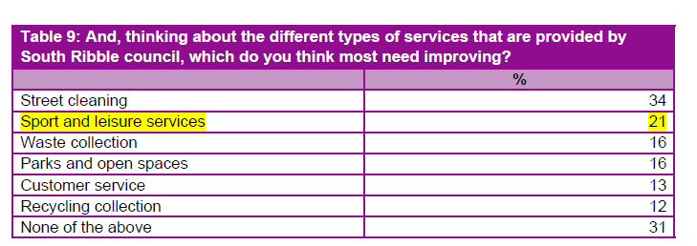

That survey also showed that 62% of residents were satisfied with sport and leisure facilities compared to 64% nationally which is the only indicator which scored below the national average.

* 1. Consultants were engaged as part of the One Public Estate (OPE) funding to liaise with partners and draw up an overall plan for the West Paddock area that could meet partner expectations and deliver a full Campus model. That work was shared with Members in the High Level Business Case that supported the Cabinet report in December 2017. This work is now forming the basis for developing a formal masterplan for West Paddock. This will be developed over the coming months and have full consultation with the community.
  2. The development of the Leyland leisure facility will include full public consultation as the design evolves as part of pre-planning consultation and those views will be incorporated into the final design submitted for planning consent in 2019.

1. **ALTERNATIVE OPTIONS CONSIDERED AND REJECTED**
   1. This report defines the priorities for spending in 2018/19. Other packages of work have been identified but will come forward as further funding is released.
2. **Financial implications**
   1. The schedule of works for which approval is sought is within the Capital Strategy approved by the Council on 28th February 2018. The report seeks Cabinet approval to incur expenditure on this programme of works in line with Council procedures.
3. **LEGAL IMPLICATIONS**
   1. The report identifies approvals to incur expenditure in line with the Council procedures. Proper procurement routes will be followed to secure contractors for the green links and construction works.
   2. Section 6.5 discusses at length the procurement of a development team to deliver the new leisure facility in Leyland. Use of a framework is an appropriate route to secure the skills to deliver this project. The Council have authority to use the framework recommended and this has followed proper procurement advice.
4. **Human Resources and Organisational Development implications**
   1. At this stage there is no direct human resources issues. The schemes identified will be managed under the Council’s project management processes and will help develop and integrate the new ways of working.
5. **ICT/technology implications**
   1. There are no direct ICT implications at this stage. Support on the utilisation of new technologies within the new facility may be required further down the design route.
6. **Property and Asset Management implications**
   1. Investment in the green infrastructure will create some additional maintenance issues within the Council ownership. However, the “Our Green Links” Strategy looks to minimise the impact and accommodate it within the existing resources.
   2. Investment in Penwortham Holme drainage will bring the playing pitches back into use and accommodate over 1000 children playing non-competitive football each weekend in a managed controlled environment providing for all U7’s and U8’s Football across the Central Lancashire footprint, with close on 100 teams using the facilities. Proper drainage will allow for the management and maintenance regime to be delivered.
   3. The damaged Pavilion is currently out of use and continues to deteriorate. Allocating the funding in this report will bring the facility back into use and will ensure that there is proper, 21st century provision for the 1,000’s of young players using the facility. It will also have a positive impact on future maintenance liabilities to the Council. The modernised facility will reduce annual maintenance.
7. **RISK MANAGEMENT**
   1. A key risk to delivery of the Campus Programme and resident expectation is stalling the start of the design of the leisure element of the Leyland Campus. Approving recommendation 16.2 mitigates this risk and allows the Council to proceed but with flexibility to control costs.
   2. Cabinet release funds to deliver the detailed schemes within this report in line with the previously approved High Level Business Case. This decision allows procurement of a contractor to deliver the works for the green infrastructure immediately after Cabinet. Any delay in this decision could lead to the whole programme being delayed and not delivered in 2018/19.
   3. Currently Penwortham Holme Recreation Centre is unusable with a damaged deteriorating pavilion. Approving the expenditure within this report mitigates that asset deteriorating further but, more importantly, will enable an effective junior football programme within the Borough next season. With any build programme there is a risk that costs will increase. This has been mitigated by the design expertise used and will be effectively project managed.
   4. Two major risks to the whole Campus Programme is delay in delivering the expected outcomes and increasing costs. A significant mitigation is strong programme management. The report recommends the appointment of a Programme Director with extensive experience to support the in-house project team to help deliver on this.
8. **EQUALITY AND DIVERSITY IMPACT**
   1. The whole Campus Programme is about improving access for all green spaces, parks and leisure opportunities. The design of the green links will meet the highest accessibility standards and the new facilities will enable a wider provision of leisure and cultural activities. An equality Impact Assessment will be undertaken throughout the project.
9. **RELEVANT DIRECTORS RECOMMENDATIONS**
   1. Cabinet approve the schedule of works described in section 6 including Project Management, Green Infrastructure (Green links identified in Appendix C for 2018/19), Existing Built Assets, Leisure Facility and Sports Pitch Hub which are within the approved Capital Strategy and grant authority to spend on those schemes;
   2. Cabinet endorse the procurement route for developing the leisure element of the Leyland Campus and approve the procurement of the development team via a single source, direct award framework as described in section 6.5. (Pagabo/perfect Circle Framework);
   3. Cabinet authorise the commencement of work on the Leyland Campus Master Plan including public consultation which will then be submitted to Planning Committee at a later date.
10. **COMMENTS OF THE STATUTORY FINANCE OFFICER**
    1. The budget for this proposal has been agreed as part of the Council’s capital programme. The appointment of a consultant to support the design process will provide the council with an opportunity to review detailed costs of the proposal against the available funding before progressing to the next phase. Any variation in costs and funding will need to be considered at that time.
11. **COMMENTS OF THE MONITORING OFFICER**
    1. Please see the legal implications section above. Clearly our campus programme is an ambitious one with significant expenditure attached to it. Any contractual documentation to be entered into will be thoroughly checked by Legal Services. Clearly we must ensure that we comply with procurement rules throughout. In this context the proposal to appoint a development team to secure the delivery of a new leisure facility through a framework agreement is entirely appropriate. The successful delivery of this programme as a whole will required effective liaison between internal staff and external contractors/consultants. Effective project management is essential.
12. **BACKGROUND DOCUMENTS**

**Cabinet on 6th December 2017** **Health, Leisure and Well-Being Campuses**

**Cabinet on 25th January 2018 Financial Case for Health, Leisure & Well Being Campus Programme**

1. **APPENDICES**

**Appendix A** **Capital Strategy 2018/19 to 2022/23**

**Appendix B** **Programme Director for Health and Well Being in South Ribble**

**Appendix C (i) ROUTE 1**

**Appendix C (ii) ROUTE 2**

**Appendix C (iii) ROUTE 3**

**Appendix C (iv) ROUTE 4**

**Jennifer Mullin**

**Director of Neighbourhoods & Development**

|  |  |  |
| --- | --- | --- |
| Report Author: | Telephone: | Date: |
| Noel O’Neill | 01772 625361 | 26th April 2018 |

**Appendix A**

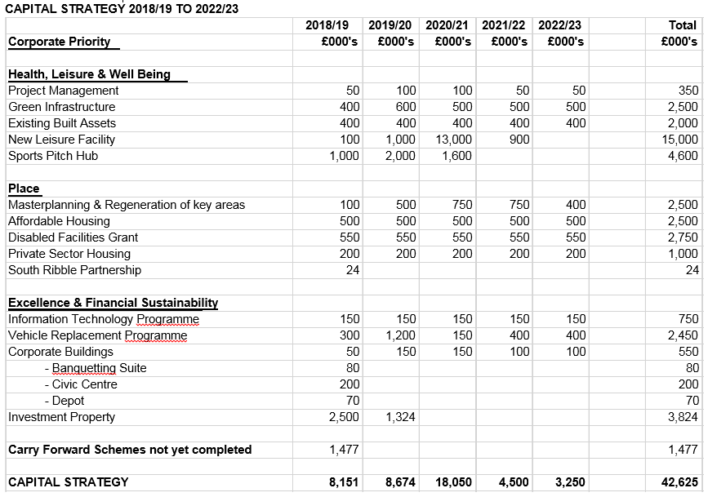

**Appendix B**

**Programme Director for Health and Well Being in South Ribble**

**Purpose of the programme director role**

The programme director is the client-side representative, acting as a single point of contact with Project Managers for the day-to-day management of the interests of the client organisation. This role will act as liaison with Deputy Chief Executive, Senior Responsible Officer (SRO), for the whole programme. The Programme Director may perform some of the duties of SRO on a day-to-day basis.

The Programme Director will set out the deliverables of the Programme for the next 5 years and act as a focal point between the business and the Project Managers ensuring delivery and reporting to Members as appropriate. The role is responsible for ongoing management to ensure that desired programme outcomes and objectives are delivered.

**Specific responsibilities of the programme director**

The programme director is responsible for:

* ensuring an appropriate programme and project management framework is in place;
* preparing the programme brief, project initiation documents and business case among other documents;
* appraising options and submitting for approval in a timely manner;
* securing appropriate resources and expertise as required to deliver the programme;
* determining and managing risks to the programme;
* managing the programme budget;
* establishing formal reporting arrangements on programme progress;
* management of change control of the programme or projects;
* assisting the Project Manager to resolve any problems that arise and escalate matters that need further decisions;
* reviewing detailed reports on the programme from the Project Manager ensuring decisions are made in a timely manner;
* promoting regular dialogue with contractors solve problems and minimise costs.

**Skills and attributes needed by the programme director**

The Programme Director should be able to:

* demonstrate extensive experience of managing large programmes;
* apply quality management principles and processes;
* apply risk assessment and management principles and processes;
* network effectively, negotiate well and influence people;
* broker relationships with stakeholders within and outside the programme;
* be aware of the broader perspective and how it affects the programme;

**Appendix C (i)**

**ROUTE 1 - PENWORTHAM TO BAMBER BRIDGE, INCLUDING LONGTON AND MIDDLEFORTH**

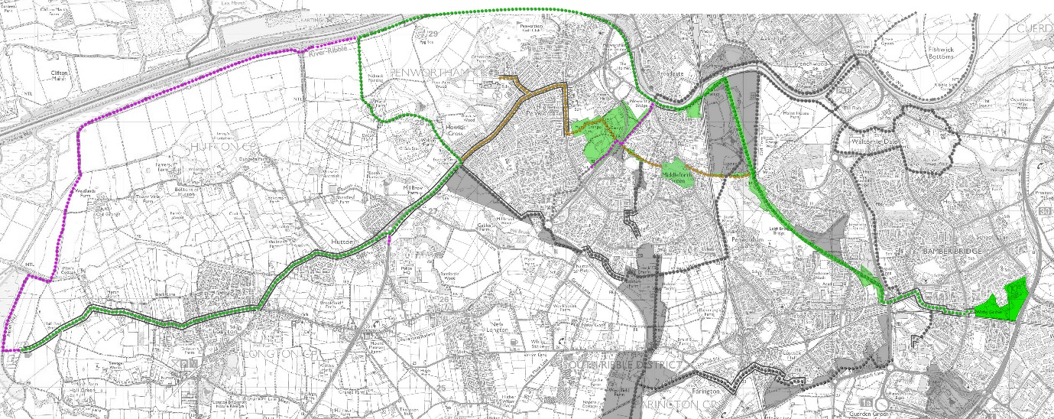

**BUDGET £97 000**

* Path improvements 40 000
* Road crossing upgrades 34 000
* Surface markings 5900
* Entrance improvements 4500
* Signage 12 600

97 000

**OUTCOMES**

* Increased numbers of walkers, cyclists and horse riders in all age groups, using the routes for work, leisure and events
* Increased accessibility for disabled users joining public rights of way at access points from highways
* Integration into proposed Penwortham initiatives including the Penwortham Cycle Loop and town centre improvements
* Encouraging sustainable links to Western Parishes
* Installation of new signage to create cohesive routes and improve legibility of directions and destinations
* Install interpretation material in key locations, integrated with online information using new and existing web sites

**Appendix C (ii)**

**ROUTE 2 - BAMBER BRIDGE LEISURE CENTRE VIA WITHY GROVE PARK TO TENNIS CENTRE USING MEANYGATE**

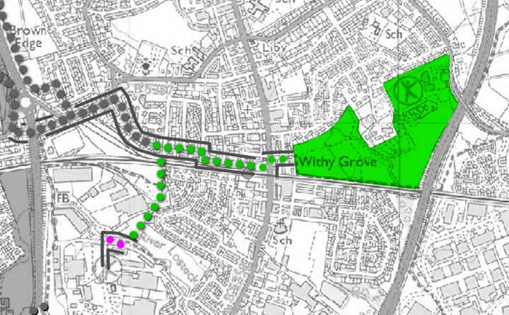

**BUDGET £16 000**

* Signage and surface markings 11700
* Bridge improvements 2500
* Vegetation improvements 1800

16 000

**OUTCOMES**

* More attractive and safer links for walkers and cyclists from the park to the leisure centre
* Increased accessibility for disabled users at access points from highways
* New signage to improve legibility of directions

**Appendix C (iii)**

**ROUTE 3 - RIBBLE LINKS AND CONNECTIONS TO CENTRAL PARKS**

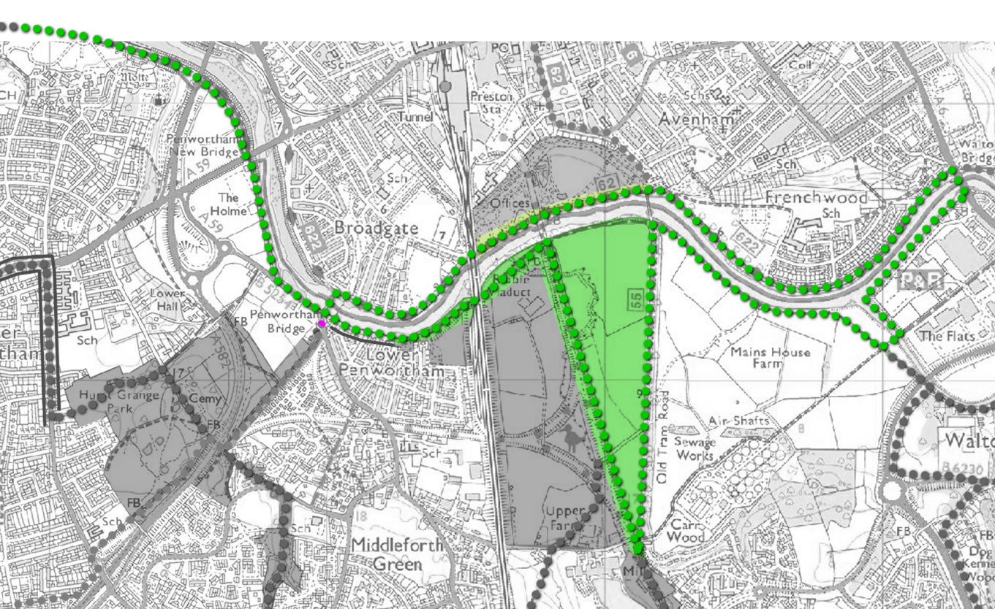

**BUDGET £36 000**

* Path improvements 18 000
* Signage 11 650
* Vegetation improvements 6350

36 160

**OUTCOMES**

* Increased numbers of walkers, cyclists and horse riders in all age groups, using the routes for work, leisure and events
* Increased accessibility for disabled users joining public rights of way at access points from highways
* Increased activity and projects managed by volunteer groups in conservation
* Increased areas of new habitats, including improved areas by the control of invasive species and regeneration of poor quality vegetation
* Installation of new signage to create cohesive routes and improve legibility of directions and destinations
* Install interpretation material in key locations, integrated with online information using new and existing web sites
* Produce a calendar of events planned for 2018-2019 in the areas of Penwortham-Middleforth, Walton Park and Walton-le-Dale. Include cross-river events involving Avenham and Miller Park, Fishwick Bottoms and Sustrans routes 55 and 62

**Appendix C (iv)**

**ROUTE 4 - CENTRAL PARKS**

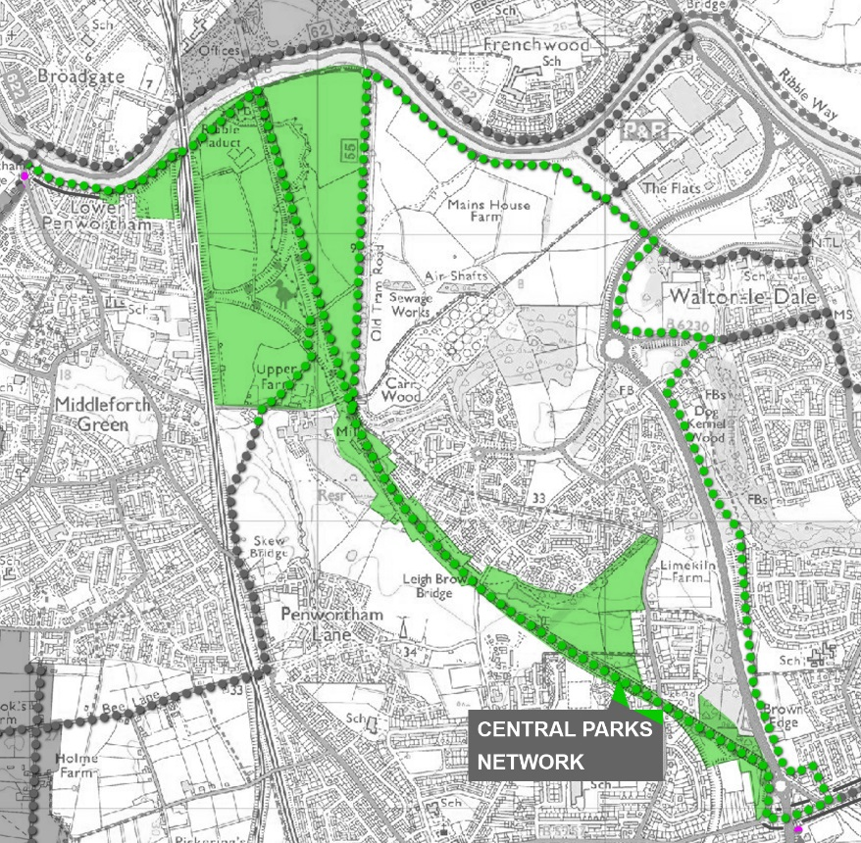

**BUDGET £126 000**

* Path construction 97 325
* Entrance improvements 17 000
* Signage 11 675

126 000

**OUTCOMES**

* Increased numbers of walkers, cyclists and horse riders in all age groups, using the network for work, leisure and events
* Increased accessibility for disabled users joining public rights of way at access points from highways
* Improved footpath through Dog Kennel and Cockshott Woods
* Continued management of the Friends of Preston Junction Local Nature Reserve volunteers
* Implementation of the Preston Junction LNR Management Plan
* Installation of new signage and interpretation material
* Develop the conditions necessary to implement a Forest Schools education programme and formal physical health programme